FIFO Page Replacement

DHIVYA SHREE K

230701079

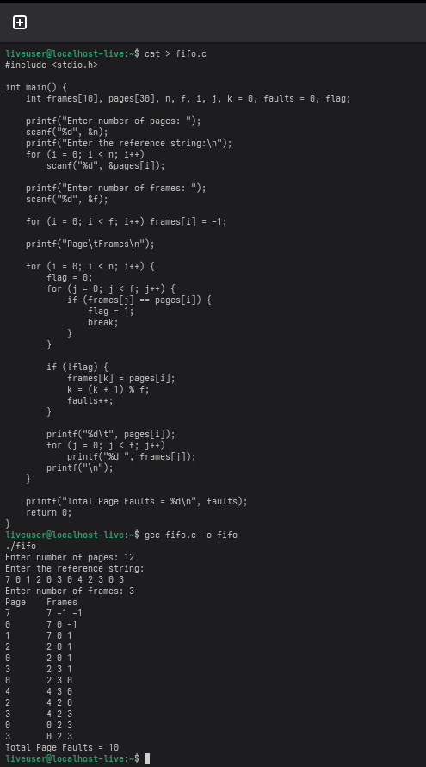

LRU Page Replacement

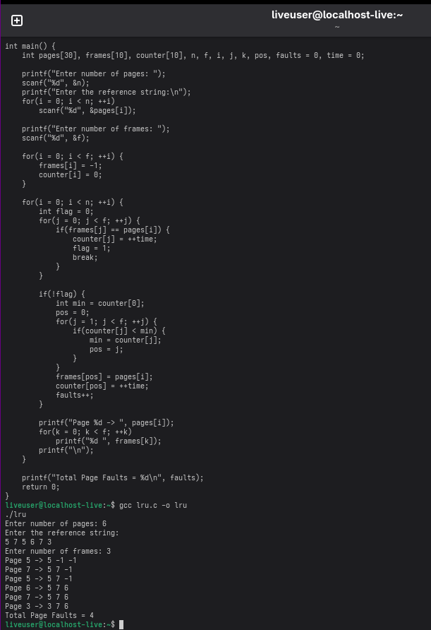

Optimal Page Replacement

